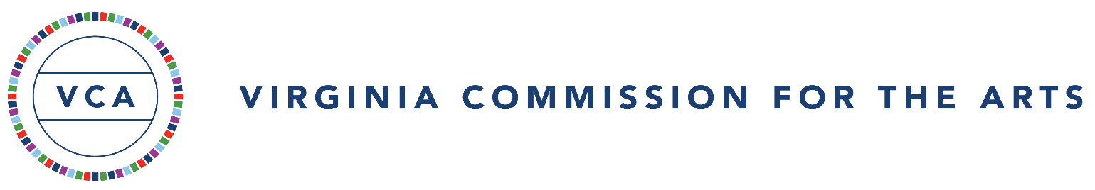

Certification of Assurances and Grant Conditions
2024-2025 Creative Community Partnership Grants (CCPG)

Virginia Commission for the Arts (Commission) grantees are required to be nonprofit Virginia organizations and exempt from federal income tax under Section 501(a), which includes the 501(c)(3) designation of the Internal Revenue code, or are units of government, educational institutions, or local chapters of tax-exempt national organizations. No part of any Commission grant shall be used for any activity intended or designed to influence a member of Congress or the General Assembly to favor or oppose any legislation.
Commission CCPG matching funds must be sub-granted by the local or tribal government to independent, ADA-compliant arts organizations for arts activities in the locality, including activities that promote cultural equity and access. The Commission does not match payments paid to performers for specific performances. Local governments seeking such funding should apply for Virginia Touring Grants, if applicable.
*SAM.gov Unique Entity Identifier (UEI)
In April 2022, the federal government transitioned from the use of Data Universal Numbering System (DUNS) numbers to a new Unique Entity Identifier (UEI) through the SAM.gov system as the primary identifier. As a recipient of federal funding through the National Endowment for the Arts, the Virginia Commission for the Arts also requires UEI numbers on all grant applications from nonprofit organizations and units of local and tribal government. Applicants who have not already done so must register with SAM.gov to be issued a 12-character, Unique Entity ID (UEI). There is no fee for registering for a UEI.

Each Creative Community Partnership Grantee must:
- read and review the 2024-2025 Guidelines for Funding before applying;
- maintain and provide complete and accurate records of all activities connected with the grant;
- maintain effective control over and accountability for all funds, property, and other assets ensuring that assets are used solely for authorized purposes;
- provide the Commission, or its authorized representatives, access to the grant-related financial records if required;
- expend any and all grant funds only for purposes described in the application form and attachments.
- maintain procedures ensuring timely disbursement of funds;
- request permission in writing to make changes to the proposed sub-grantees, budget, schedule, program and or personnel. The requested changes must be approved in advance by the Commission;
- local or tribal governments that receive more than $750,000 in federal funding from expenditures from Commonwealth agencies must submit a Single Audit.
Each Commission grantee will comply with these federal statutes and regulations:

- Title VI, Section 601, of the Civil Rights Act of 1964, which provides that no person, on the ground of race, color or national origin, shall be excluded from participation in, be denied the benefits of, or be subjected to discrimination under any program or activity receiving federal financial assistance.

- Title IX, Section 1681, of the Education Amendments of 1972, which provides that, with certain exceptions, no person, on the basis of sex or age, shall be excluded from participation in, be denied the benefits of, or be subjected to discrimination under any education program or activity receiving federal financial assistance.

- Section 504 of the Rehabilitation Act of 1973, as amended, and the Americans with Disabilities Act of 1990 which states that no otherwise qualified person shall, solely by reason of his or her handicap, be excluded from participation in, be denied the benefits of, or be subjected to discrimination in federally assisted programs. Compliance with this Act includes the following: notifying employees and beneficiaries of the organization that it does not discriminate on the basis of handicap and operation of programs and activities which, when viewed in their entirety, are accessible to persons with disabilities. Compliance also includes maintenance of an evaluation plan developed with the assistance of persons with disabilities or organizations representing disabled persons which contains: policies and practices for making programs and activities accessible; plans for making any structural modifications to facilities necessary for accessibility; a list of the persons with disabilities and/or organizations consulted; and the name and signature of the person responsible for the organization’s compliance efforts (“ADA Coordinator”).

Reporting Requirements/Payment Procedures
Each local or tribal government will confirm that its governing board has appropriated the matching funds by completing the online CCPG FY25 Final Report/Confirmation Form. The final report/confirmation must include:
- a list of the sub-grantee organizations that received funding
- total funding awarded to each organization, including a breakout of the Commission’s $ share and the local government’s $ share
- the appropriate page of the local or tribals government’s approved FY25 budget showing the amount of the award and match
- copy(ies) of the check(s) to the sub-grantee(s)
The Commission will pay the grant in full approximately 30 days after receiving this final report/confirmation.
The deadline for this confirmation is February 1, 2025.
This application must be physically signed by an individual duly authorized by the governing body of the locality to act on its behalf and submitted with every grant application made to the Commission.
Authorizing officials include: county administrators, mayors, city/town managers, tribal leaders, etc. The signature of the individual indicates the locality’s compliance with all the grant conditions listed above.

The undersigned certifies to the best of his/her knowledge that:
- the information in this application and its attachments are true and correct;
- the applicant organization agrees to comply with all grant conditions cited above;
- the applicant organization and subgrantees are fully operational and anticipate remaining in business for the duration of the award period; and
- the locality and subgrantees are not currently under suspension or debarment by the federal government. Visit SAM.gov. to confirm status.
- the filing of this application has been duly authorized by the governing body of the applicant organization;

Local or Tribal Government Name:
Typed Name of Authorizing Official: Title:
Physical Signature of Authorizing Official: ________________________________ Date:

Email of the Authorizing Official:
NOTE: Only documents with original signatures will be accepted.

