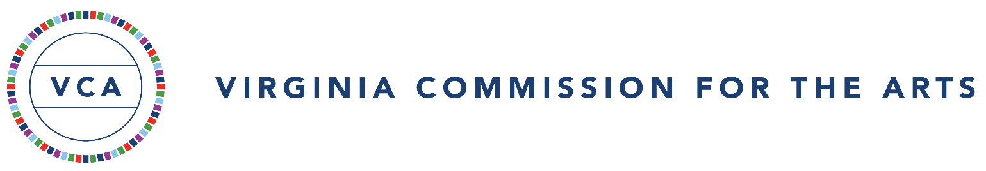

Certification of Assurances and Grant Conditions
2024-2025 Community Impact Grant

Virginia Commission for the Arts (Commission) grantees are required to be nonprofit Virginia organizations and exempt from federal income tax under Section 501(a), which includes the 501(c)(3) designation of the Internal Revenue code, or are units of local or tribal government, educational institutions, or local chapters of tax-exempt national organizations. Community Impact Grants are limited to 50% or less of cash costs of any activity funded.
*SAM.gov Unique Entity Identifier (UEI)
In April 2022, the federal government transitioned from the use of Data Universal Numbering System (DUNS) numbers to a new Unique Entity Identifier (UEI) through the SAM.gov system as the primary identifier. As a recipient of federal funding through the National Endowment for the Arts, the Virginia Commission for the Arts also requires UEI numbers on all grant applications from nonprofit organizations and units of government. Applicants who have not already done so must register with SAM.gov to be issued a 12-character, Unique Entity ID (UEI). There is no fee for registering for a UEI.

Each Commission grantee will:

- read and review the 2024-2025 Guidelines for Funding before applying;
- maintain and provide complete and accurate records of all activities connected with the grant;
- maintain effective control over and accountability for all funds, property, and other assets ensuring that assets are used solely for authorized purposes as described in the application form and attachments;
- provide the Commission, or its authorized representatives, access to the grant-related financial records if required;
- use no part of a Commission grant for an activity intended or designed to influence a member of Congress or the General Assembly to favor or oppose any legislation
- notify the Commission of any substantial changes in its budget, programming, and key personnel related to this grant. Failure to do so will affect current and future funding.

Each Commission grantee will comply with these federal statutes and regulations:

- Title VI, Section 601, of the Civil Rights Act of 1964, which provides that no person, on the ground of race, color or national origin, shall be excluded from participation in, be denied the benefits of, or be subjected to discrimination under any program or activity receiving federal financial assistance.

- Title IX, Section 1681, of the Education Amendments of 1972, which provides that, with certain exceptions, no person, on the basis of sex or age, shall be excluded from participation in, be denied the benefits of, or be subjected to discrimination under any education program or activity receiving federal financial assistance.

- Section 504 of the Rehabilitation Act of 1973, as amended, and the Americans with Disabilities Act of 1990 which states that no otherwise qualified person shall, solely by reason of his or her handicap, be excluded from participation in, be denied the benefits of, or be subjected to discrimination in federally assisted programs. Compliance with this Act includes the following: notifying employees and beneficiaries of the organization that it does not discriminate on the basis of handicap and operation of programs and activities which, when viewed in their entirety, are accessible to persons with disabilities. Compliance also includes maintenance of an evaluation plan developed with the assistance of persons with disabilities or organizations representing disabled persons which contains: policies and practices for making programs and activities accessible; plans for making any structural modifications to facilities necessary for accessibility; a list of the persons with disabilities and/or organizations consulted; and the name and signature of the person responsible for the organization’s compliance efforts (“ADA Coordinator”).

Reporting Requirements
Each grantee will submit a final report to the Commission within thirty (30) days of the end of the grant period and no later than June 1, 2025. The final report can be found on the applicant’s online “dashboard” under Follow Ups. Failure to submit this report may jeopardize any future grant being accepted by the organization and may result in the organization being required to repay grant funds.

Funding Acknowledgement
All print and digital material regarding the particular activity supported must acknowledge that the activity is partially supported by a grant from the Virginia Commission for the Arts (VCA) and the National Endowment for the Arts. The purpose of crediting the Virginia Commission for the Arts and the National Endowment for the Arts is to provide citizens with an accurate picture of the broad range of arts activities supported by their tax dollars. Additionally, this acknowledgement serves as an endorsement for the organization and its activity and often leverages additional support.

The logos of the Virginia Commission for the Arts and the National Endowment for the Arts, as well as funding credit, are available for download from the Commission’s website www.vca.virginia.gov. This acknowledgment is to be included in programs, print and online newsletters, educational materials, brochures, posters, news releases, web sites, catalogues, videos, and recognized in curtain speeches and other special events as appropriate. However, as neither agency funds expenses related to fundraisers, logos/recognition should not be included in such related materials.

NOTE: As of September 2022, the Virginia Commission for the Arts uses a new logo, and all funding acknowledgments must reflect the new logo.

This form must be submitted with every Commission grant application and signed by an individual duly authorized by the governing body of the organization to act on its behalf (such as the Executive Director, Artistic Director, Board President/Chair/Treasurer). The signature of the individual indicates the organization’s compliance with the grant conditions listed above. NOTE: Only documents with original signatures will be accepted. A duly authorized individual must also sign the final report form.
The undersigned certifies to the best of his/her knowledge that:
the information in this application and its attachments is true and correct;
- the filing of this application has been duly authorized by the governing body of the applicant organization;
- the applicant organization agrees to comply with all grant conditions cited above;
- the applicant organization is fully operational and anticipates remaining in business for the duration of the award period; and
- the organization is not currently under suspension or debarment by the federal government. If you are uncertain of your status, visit SAM.gov.

The undersigned further certifies that he or she has the legal authority to obligate the applicant organization.

Applicant Organization Name:
Typed Name of Authorizing Official: Title:
Original Signature of Authorizing Official: ________________________________ Date:
Email of the Authorizing Official:

