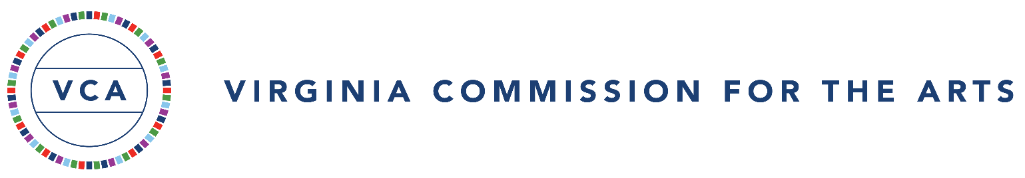
The Virginia Commission for the Arts (VCA or Commission) Artist Catalyst Grant provides a one-time award of $500 to an individual Virginia artist for an approved activity that advances their creative practice. No matching funds are required. This Certification of Assurances and Grant Conditions must be signed and submitted after award and before grant payment.

Certification of Assurances and Grant Conditions FY27 Artist Catalyst Grant

Each Commission grantee will:
- review and comply with the FY27 Artist Catalyst Grant guidelines, approved application, award letter, and these grant conditions;
- remain eligible as an individual grantee, including meeting the Virginia residency and age requirements; not being a full-time student or a VCA Roster Artist; and not being under current federal suspension or debarment;
- use the grant only for eligible activities and expenses identified in the approved application and incurred within the approved activity dates;
- obtain VCA approval before making substantial changes to the approved activity, budget, or activity dates, and notify VCA promptly of changes to contact or mailing information;
- maintain accurate receipts and payment records supporting grant expenditures for five (5) years and provide these records to VCA or its authorized representatives upon request;
- use no portion of the grant for lobbying, political advocacy, or another activity prohibited by applicable state or federal law.

Use of Grant Funds
Grant funds may not be used for virtual programming; ongoing costs such as rent, studio fees, subscriptions, web hosting, or regular lessons; routine job-related expenses; travel costs (transportation, lodging, or meals); activities outside the United States; or credit-bearing coursework. Other restrictions in the FY27 Artist Catalyst Grant guidelines also apply. If the approved activity includes an equipment or other integral purchase, VCA may contribute up to $500 toward a purchase with a total cost not exceeding $3,000.

Award Acceptance and Payment
The artist must upload this signed certification and a completed, signed Virginia W-9 through the Foundant applicant account by the deadline stated in the award letter (November 2, 2026, for Cycle 1 awards). VCA will issue payment by check to the mailing address on the Virginia W-9. That address must match the address in the grant application; any difference must be resolved before payment. Funding is subject to action by the Governor and General Assembly.

Public Access and Applicable Laws
If the funded activity includes a performance or display for an audience, it must be open to the general public and take place in an ADA-compliant facility. The artist agrees to comply with applicable federal and Virginia laws, including nondiscrimination and accessibility requirements. Depending on the funded activity and the law’s applicability, these include Title VI of the Civil Rights Act of 1964; Title IX of the Education Amendments of 1972; the Age Discrimination Act of 1975; the Americans with Disabilities Act; Section 504 of the Rehabilitation Act of 1973; and the Virginia Human Rights Act.

Final Reporting Requirements
A Final Report must be submitted in Foundant within thirty (30) days after completion of all grant-funded activities. For activities taking place June 1–15, 2027, the final deadline is June 16, 2027. The report will require the artist to confirm the activity dates, describe any changes to the approved activity or expenses, report the total VCA grant funds spent, and briefly describe how the grant supported the artist’s practice or professional development.

The artist must upload one combined file containing receipts, paid invoices, or other proof of payment documenting the VCA grant funds spent and electronically certify the accuracy of the Final Report. VCA may request additional documentation or clarification if needed.

Final Reporting Violations and Consequences
Failure to submit a complete Final Report by the deadline may affect eligibility for future VCA funding. Unspent funds or funds used for ineligible or unauthorized purposes may be subject to repayment in accordance with the grant conditions and applicable law. Artists should contact VCA before the reporting deadline if exceptional circumstances may prevent timely submission.

Funding Acknowledgment
If applicable, when producing public-facing materials related to your grant-funded activity, please acknowledge support from the Virginia Commission for the Arts. Approved credit language and logos are available on the VCA website under Grants. VCA credit and logos should not be included on fundraising materials.

Certification by Individual Artist
By signing below, I certify that the information provided in my Artist Catalyst Grant application and supporting materials is true and correct to the best of my knowledge; that I meet the grant eligibility requirements; and that I have read, understand, and agree to comply with the conditions above. I acknowledge my responsibility to document the use of grant funds, submit the required Final Report, and return funds if repayment is required under the grant conditions.

Artist’s Legal Name (Type) - as shown on VA W-9:
Signature of Artist (Physical) Signature: Date :

Email Address (Type):

